Assignment -4

Docker and Kubernetes

|  |  |
| --- | --- |
| Assignment Date | 8 November 2022 |
| Student Name | Subarna vishalli.S |
| Student Roll Number | 727719EUIT165 |
| Maximum Marks | 2 Marks |

1. **Pull an image from docker hub and run it in docker Playground**

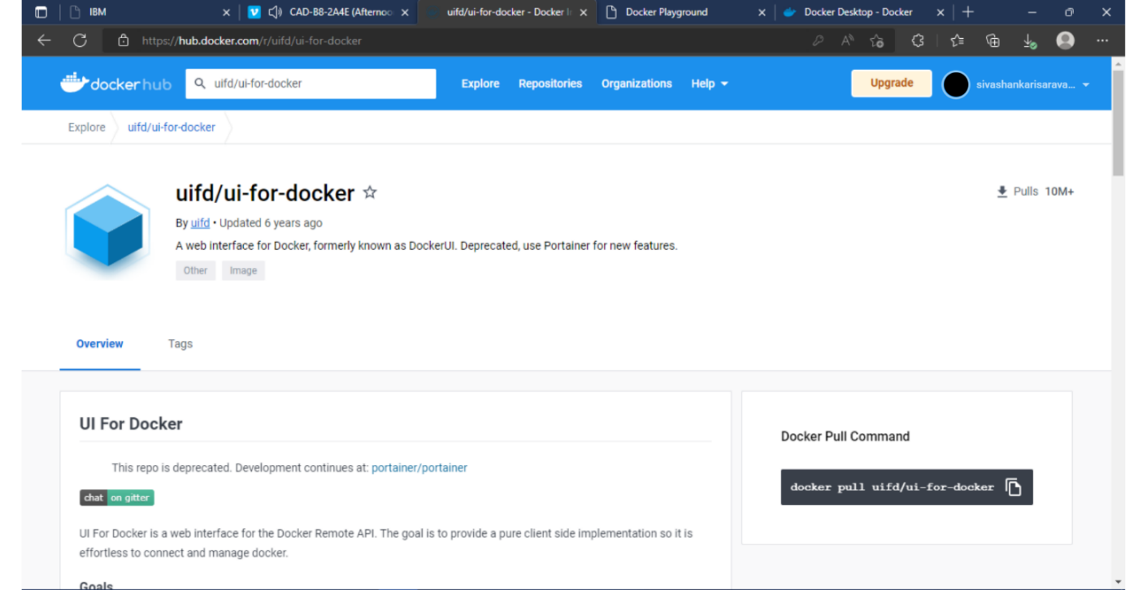

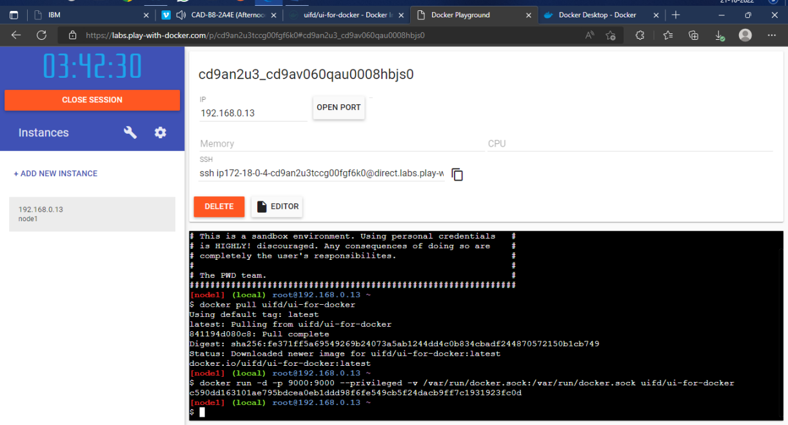

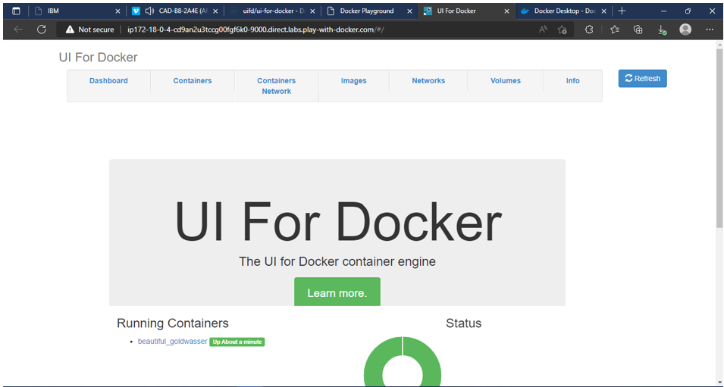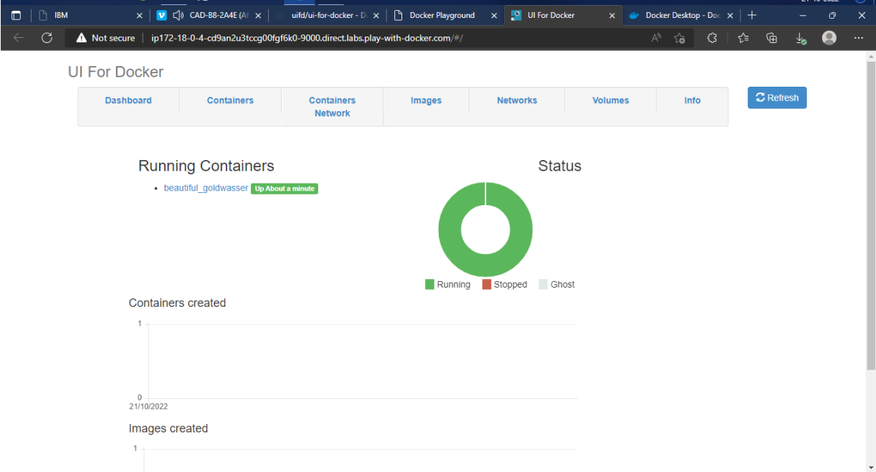

**2.Create a docker file for the job portal application and deploy it in Docker desktop application**

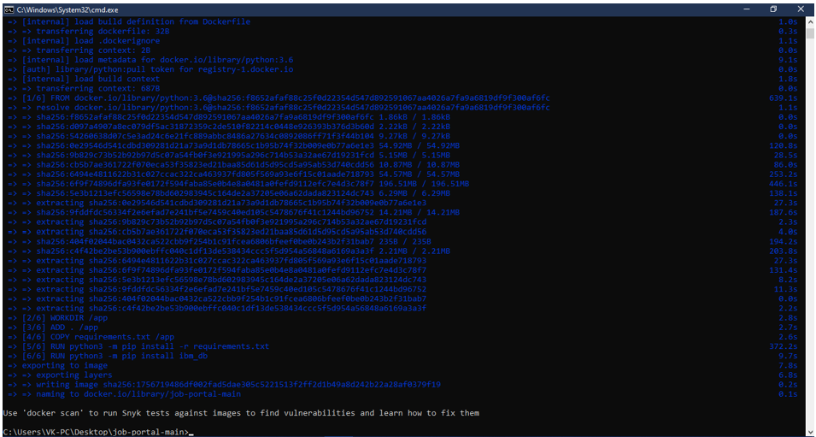

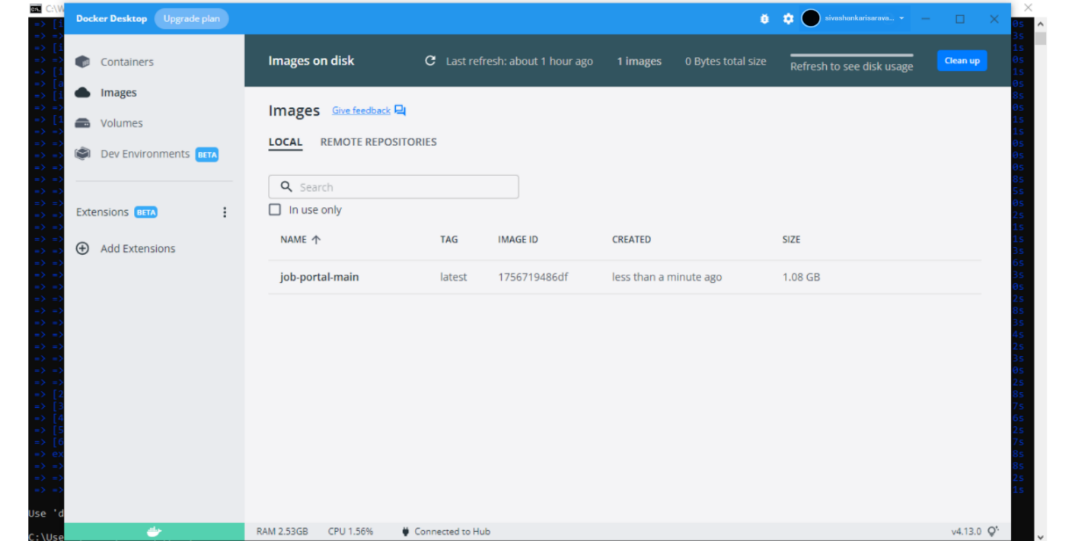

**3.Create a IBM container registry and deploy helloword app**